Part A:-

1.State the Null and Alternative Hypothesis (2).

Null Hypothesis (h0) : Purple Flowers Percentage is equal to 75% and chance of 25% are white flowers.

Alternate Hypothesis(h1):Mendel’s Hypothesis is False

2.What statistic do you recommend to apply for this case(2)?

Z-Test can be performed since n>30 or it has more samples i.e. 929.

3. State the observed statistic(2)

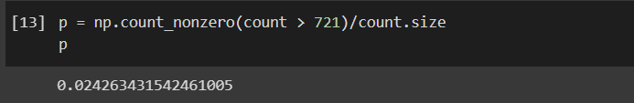

4.Simulate the test statistic under the Null that will help make the decision(5). The number of simulations should be equal to (2000 - “Last 3 digits of your Roll Number”).

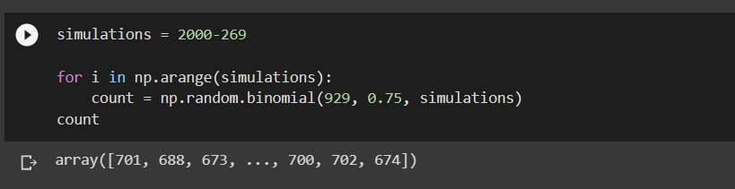

5. Draw a histogram to depict what the model of random selection predicts about the statistic.(4). Depict the observed statistic as a 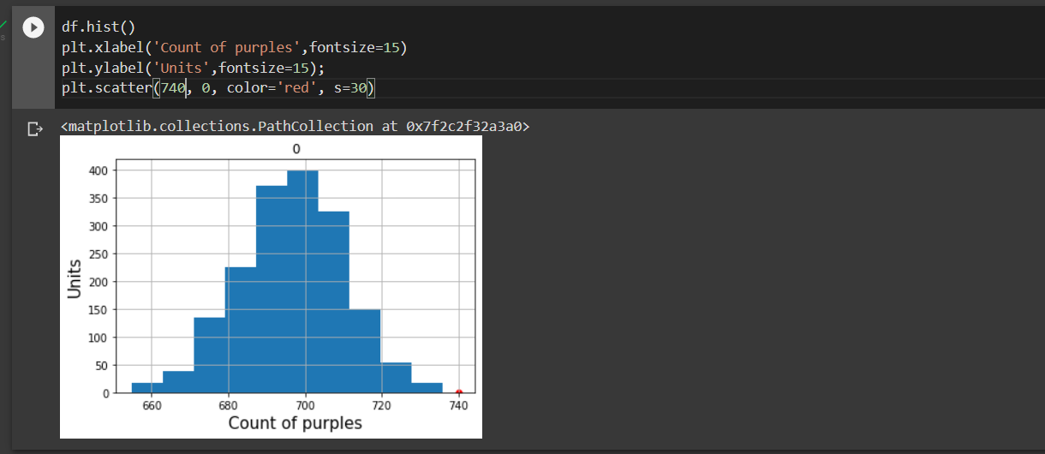red dot on the histogram(1).

6. What is the outcome of your analysis? (1)

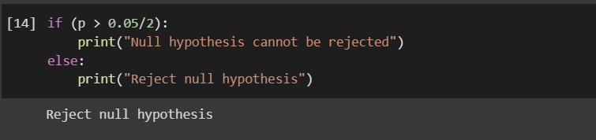

Part B:-

